## 1. Simple Network

1. Create a new project in Packet Tracer
2. In bottom left corner click on End Devices
3. Drag-and-Drop two generic PC to the canvas
4. In bottom left corner click on Hub
5. Drag-and-Drop a Hub to the canvas
6. Connect both PCs to the Hub (use either automatic connection or copper straight through from the connection item in bottom left corner).
7. For both PCs in turn, click on the PC, choose tab “Config” and select Interface->Fast Ethernet and assign addresses 192.168.1.1 and 192.168.1.2, respectively (both with subnet mask 255.255.255.0)
8. Click on PC with address 192.168.1.1, select Desktop-Command Prompt and enter “ping 192.168.1.2”: you should get a successful ping reply.
9. Select Simulation Mode in the bottom right corner, select “Add Simple PDU” on the right hand side of the screen and click once on both PCs in turn. Click “Auto Capture/Play” and watch as packets travel through your network.

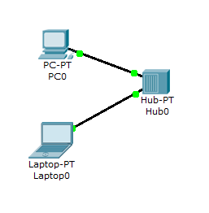

## 2. Two Networks – one Router only

* 1. Create 3 PCs with IP addresses 192.168.1.10/20/30 (subnet 255.255.255.0) connected through a Switch. For each PC set default Gateway to 192.168.1.1.
  2. Create 3 PCs with IP addresses 192.168.2.10/20/30 (subnet 255.255.255.0) connected through a Switch. For each PC set default Gateway to 192.168.2.1.
  3. Add a Router 1841
  4. Select Connection->Copper Straight Through, click on the Switch connected to 192.168.1.1 and select a port, then click on Router 1841 and select “FastEthernet 0/0”
  5. Click on Router 1841, select Config->FastEthernet 0/0 and enter IP address 192.168.1.1, subnet 255.255.255.0 and tick box “Port Status on”
  6. Click on Router 1841, select Config->FastEthernet 0/1 and enter IP address 192.168.2.1, subnet 255.255.255.0 and tick box “Port Status on”
  7. Wait until all light have gone green. On each PC 192.168.1.10/20/30 choose Command Prompt and ping all machines 192.168.2./10/20/30. If you receive only “time out” messages, wait for a short time and try again. If it still fails, check your settings (IP addresses, subnet mask, default gateway).
  8. On each PC 192.168.2.10/20/30 choose Command Prompt and ping all machines 192.168.1./10/20/30
  9. 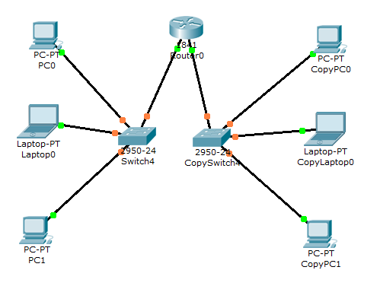Repeat step h with “Add Simple PDU” in Simulation Mode. Make sure to set the Event Filter List (bottom right corner) to ARP and ICMP only. If you receive a message “Event Buffer full” simply clear the event buffer and press “Auto Capture/Play” again.

## 3. Two Networks, Two Routers, Static Routing

(For steps a and b you can re-user the network from exercise 1-2)

* 1. Create 3 PCs in with IP addresses 192.168.1.10/20/30 (subnet 255.255.255.0) connected through a Switch. For each PC set efault Gateway to 192.168.1.1.
  2. Create 3 PCs in with IP addresses 192.168.2.10/20/30 (subnet 255.255.255.0) connected through a Switch. For each PC set Default Gateway to 192.168.2.1.
  3. Add two Routers 1841
  4. Select Connection->Copper Straight Through, click on the Switch connected to 192.168.1.1 and select a port, then click on 1841 Router0 and select “FastEthernet 0/0”
  5. Click on 1841 Router1, select Config->FastEthernet 0/0 and enter IP address 192.168.1.1, subnet 255.255.255.0 and tick box “Port Status on”
  6. Click on Router1 1841, select Config->FastEthernet 0/0 and enter IP address 192.168.2.1, subnet 255.255.255.0 and tick box “Port Status on”
  7. Select Connection->Copper Cross Over, click on 1841 Router0 “FastEthernet 0/1” and then on 1841 Router1 “FastEthernet 0/1”. Configure the corresponding Ethernet ports on both routers as 1.1.1.1 (connected to 192.168.1.x) and 1.1.1.2 (connected to 192.168.2.x) and enter subnet mask 255.0.0.0 (don’t forget to switch the ports “on”).
  8. On the Router with addresses 192.168.1.1/1.1.1.1 select Config->Routing->Static and enter Network: 192.168.2.0, Mask 255.255.255.0, Next Hop 1.1.1.2 and click on “Add”
  9. On the Router with addresses 192.168.2.1/1.1.1.2 select Config->Routing->Static and enter Network: 192.168.1.0, Mask 255.255.255.0, Next Hop 1.1.1.1 and click on “Add”
  10. Perform ping commands from Command Prompt and Simulation as before (if you get a series of “time out” messages, wait for a minute and try again).

## 

## 4. Adding Modules to Hardware Components

1. Start with the network as outlined in exercise 3 and remove the connection between the two routers.
2. Click on one Router and on the “Physical” tab “switch” the device off (lower right side of the physical picture)
3. Drag-and-Drop module “WIC-2T” (you might need to scroll down on the modules list) onto the right slot in the physical picture.
4. Switch the device on and wait for it to reboot. After rebooting is completed, repeat the configuration of its FastEthernet 0/0 interface as in exercise 1-3.
5. Repeat steps b-d for the other router
6. Select Connections->Serial DTE, click on one Router and select “Serial 0/0/0”, click on the other Router and select “Serial 0/0/0”
7. Configure the serial ports 0/0/0 to 1.1.1.1 and 1.1.1.2, respectively (use subnet mask 255.0.0.0) and give both a clock rate of 4,000,000 (any rate will do as long as they’re both the same).
8. Configure static routing and perform ping commands as before

## 

## 5. Using RIP

1. Perform steps 4a-4g
2. Remove the static routes from both routers (Config->Routing->Static and click “remove”)
3. On Router with 1.1.1.1 select Config->Routing->RIP, enter 192.168.1.0 and click add, then enter 1.0.0.0 and click add again.
4. On Router with 1.1.1.2 select Config->Routing->RIP, enter 192.168.2.0 and click add, then enter 1.0.0.0 and click add again.
5. Select “Edit Filters” at the bottom right of the screen and add RIP packets to the filter.
6. Perform ping command as before.

## 6. Complex Network using DHCP

1. Add a Switch (generic - Switch PT – note there also is a generic Switch PT Empty that you shouldn’t add) to the canvas
2. Power the switch off and add two modules PT-Switch-NM-1FFE (this switch will model the Internet) and power it on again.
3. Add 4 routers 2620XM and provide each with a module NM-1FE-FX
4. Connect each router with fibre optics to the Switch, configure the ports of the switches within the range 1.1.1.x and switch the ports on.
5. Connect a switch to each router, configure the routers’ Ethernet interface to IP addresses 192.168.x.1 (where x is 1,2,3,4) and add at least 4 PCs to each switch - there’s no need to configure the PCs’ network addresses – this will be done later via DHCP.
6. To each switch add an End Device -> Generic (Server PT)
7. Give each Server the address 192.168.x.10, subnet mask 255.255.255.0, Gateway 192.168.x.1
8. For each Server, select Config->Services->DHCP and enter Default Gateway 192.168.x.1, Start IP 192.168.x.100, Max number of users = 10
9. For each PC select Config->Interface->FastEthernet and enable DHCP
10. Configure each Router for RIP (include both network ranges to which the router is connected)
11. Perform ping command as before to test your network (note: in simulation mode, you might encounter a lot of “Event Buffer Full” messages”)

## 7. Yet another Complex Network

Model the following network in Packet Tracer. Use serial connections between routers,

DHCP and RIP where suitable and select feasible addresses for the routers.

